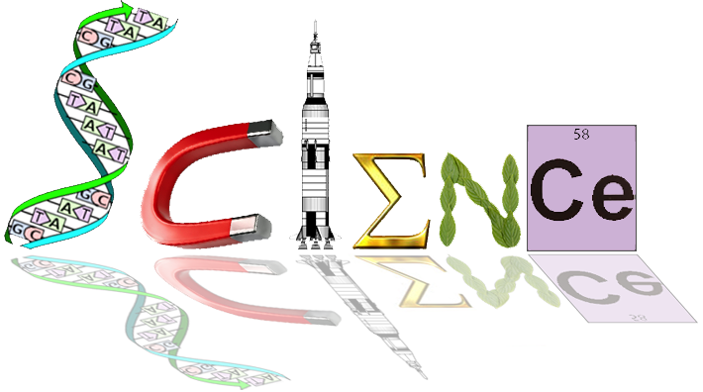

**Human Biology**

**Unit 4 – Task 11**

**Mutations and Gene Pools**

**Multiple Choice Section 20 marks**

1. A Gene Pool is
   1. The variety of phenotypes in a population.
   2. The change in allele frequencies within a population
   3. The available genotypes within a population
   4. The movement of genes in and out of a population
2. Which of the following statements is correct? As an isolated population evolves:
   1. All unfavourable alleles will be lost.
   2. Mutations will occur to suit the population to any environmental changes.
   3. There will be a greater variety of alleles in the population.
   4. The population will have a higher proportion of favourable alleles.
3. Which of the following presents the best conditions for random genetic drift?
   1. Large population, migration, natural selection
   2. Small population, Natural selection, Migration
   3. Large Population, Random mating, No mutation
   4. Small population, No Natural selection, Random mating
4. The disease variegate porphyries is relatively common in Afrikaans populations of South Africa but rare in the other races. Its inheritance can be traced back to two Dutch settlers who arrived in South Africa in the 17th century.

The incidence of this disease in the Afrikaners is an example of:

* 1. The Hardy-Weinberg law
  2. The founder effect
  3. Natural selection
  4. Random genetic drift

1. A scientist visiting the Pitcairn Islands identified 10 different nose phenotypes. The scientist concluded that these had been inherited from an original population that arrived from the mainland and then spread throughout the islands.

Which of the following would account for the development of the 10 nose phenotypes?

* 1. The different island populations were able to interbreed freely
  2. There was variation between individuals in the original population
  3. There was little variation amongst the habitats of the islands
  4. The original population was not typical of the mainland population

1. A small island in the Pacific was studied and the population was found to carry an abnormally high frequency for the gene causing Achromatoplasia (absence of colour vision). Scientists concluded that this was due to **random genetic drift**.

Which of the following is the best example of how **random genetic drift** may have caused this result?

* 1. A cyclone struck the island suddenly. Most of the survivors carried the gene for Achromatoplasia
  2. The gene for Achromatoplasia gives a survival advantage to those who possess it
  3. Those who carry this gene are more likely to find mates and more likely to have children
  4. There has been a large growth of the population in recent years

1. People living in small island communities for a number of generations without significant immigration sometimes exhibit unusual levels of genetic diseases due to recessive mutations. This is due to:
   1. Founder effects from the original first settlers
   2. A diet lacking in essential antioxidants
   3. High levels of radiation causing mutations
   4. Elevated levels of genetic mutations accumulating in the population

1. The introduction of alleles from one population into another is called
   1. mutation
   2. genetic drift
   3. gene flow
   4. natural selection
2. Selection pressure acts directly on:
   1. The phenotype of an individual
   2. The genotype of an individual
   3. The entire genome
   4. The population gene pool
3. Which of the following statements is/are correct?

i. Independent assortment of chromosomes during meiosis is a source of variation.

ii. Mutations are the only source of variation.

iii. Variation is greater within a reproductively isolated population than in one where

Interbreeding occurs with other groups.

* 1. i only.
  2. iii only.
  3. i and iii only.
  4. i, ii and iii.

1. A mutation is a sudden change in the structure of a gene. Scientists link mutations to the process of natural selection very closely. Mutations:
   1. Always produce beneficial variations upon which natural selection can act
   2. Are of importance to natural selection only if they can pass from generation to generation
   3. Will improve the survival chances of an individual
   4. Result in random genetic drift
2. Mutations that affect the reproductive cells and therefore can be passed on are called:
   1. germline mutation
   2. somatic mutation
   3. chromosomal mutation
   4. gene mutation
3. Mutations to genes on the sex chromosomes are likely to be expressed
   1. equally in males and females
   2. more frequently in females
   3. more frequently in males
   4. not at all, because they are invariably lethal
4. Which of the following is true?
   1. Mutation causes major changes in allele frequency
   2. Mutations can only occur in one direction
   3. Mutation introduces new alleles into a population
   4. Mutation does not contribute to changes in allele frequency
5. Tay-Sachs disease is due to any of several mutant alleles. One possible explanation for its prevalence in Ashkenazi populations is that the alleles provide resistance to:
   1. sickle cell anaemia
   2. tuberculosis
   3. malaria
   4. a and c
6. DNA is ‘cut’ into pieces at pre-determined or recognition sites before it can be used in genetic engineering. The enzyme(s) used for this process is/are called
   1. DNA polymerase
   2. Restriction enzymes
   3. DNA ligase
   4. Primer enzymes

Use the following information to answer the next three questions: Q17, Q18 & Q19.

To clone a gene of interest, the following four steps are performed:

1. A plasmid is cut with a specific restriction enzyme.

2. The gene of interest is ligated into the plasmid.

3. Plasmids are transferred to bacteria.

4. Bacteria are grown on four nutrient agar plates (labelled W, X, Y and Z)   
 that are coated with or without ampicillin and arabinose.

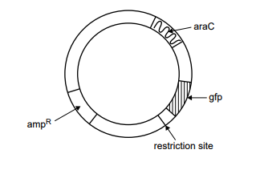An example of a plasmid used in cloning is shown below.

This plasmid contains a restriction site and the following three genes:

• ampR – confers resistance to the antibacterial agent ampicillin

• gfp – encodes the green fluorescent protein (GFP), which fluoresces under UV light

• araC – encodes a protein required to promote the expression of gfp when arabinose is present

The results from a bacterial transformation experiment are shown in the table below:

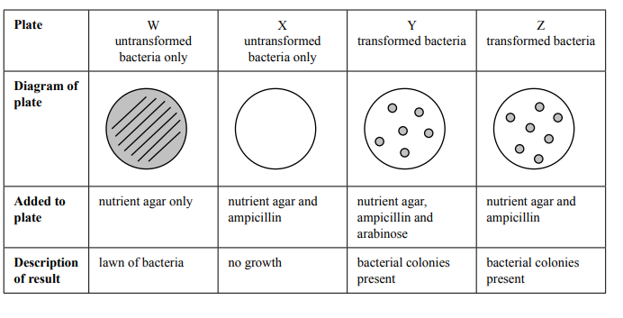

1. Bacteria are used in gene cloning because they:
   1. contain restriction enzymes that randomly cut chromosomes into fragments of varying size.
   2. can replicate non-bacterial sequences of DNA in a short time.
   3. replicate exponentially by undergoing mitotic divisions.
   4. allow the entry of foreign DNA into their nuclei.
2. Which plate would contain bacteria that fluoresce under UV light?   
   1. plate W
   2. plate X
   3. plate Y
   4. plate Z
3. Which one of the following statements is an accurate description for the purpose of plate W or X?   
   1. Plate W shows that the plasmid was cut with a restriction enzyme.
   2. Plate W shows that the percentage of transformed bacteria was high.
   3. Plate X shows that the nutrient agar promoted the growth of viable bacteria.
   4. Plate X shows that ampicillin was effective in killing the untransformed bacteria.
4. Vancomycin Resistant Enterococcus (VRE) is a significantly emerging, multi-resistant bacteria that can have devastating effects on immunocompromised hospital patients. Scientists wishing to discover how a susceptibility gene to the antibiotic vancomycin could be inserted into the wild population of the bacteria wished to use recombinant DNA technology.   
     
   Which of the below correctly describes how they would carry out the process for VRE?
   1. A susceptibility gene to clindamycin was inserted into a bacteriophage that was introduced into a culture medium containing a population of VRE. The bacteria were grown for 2 days in the medium, and then tested to see if they were still resistant to vancomycin.
   2. A susceptibility gene to vancomycin was inserted into a bacteriophage that was introduced into a culture medium containing a population of VRE. The bacteria were grown for 2 days in the medium, and then tested to see if they were still resistant to vancomycin.
   3. A susceptibility gene to clindamycin was amplified using PCR and then introduced into a culture medium containing a population of VRE. The bacteria were grown for 2 days in the medium, and then tested to see if they were still resistant to vancomycin.
   4. A susceptibility gene to vancomycin was inserted into some VRE cells in the laboratory. The bacteria were grown for 2 days in a medium, and then tested to see if they were still resistant to vancomycin.

Name: Date: Teacher:

**Year 12 Human Biology**

**Task 11: Mutations and Gene Pools**

**Total: /60**

|  |  |  |  |  |  |  |  |  |  |  |
| --- | --- | --- | --- | --- | --- | --- | --- | --- | --- | --- |
| 1 | A. | B. | C. | D. |  | 11 | A. | B. | C. | D. |
| 2 | A. | B. | C. | D. |  | 12 | A. | B. | C. | D. |
| 3 | A. | B. | C. | D. |  | 13 | A. | B. | C. | D. |
| 4 | A. | B. | C. | D. |  | 14 | A. | B. | C. | D. |
| 5 | A. | B. | C. | D. |  | 15 | A. | B. | C. | D. |
| 6 | A. | B. | C. | D. |  | 16 | A. | B. | C. | D. |
| 7 | A. | B. | C. | D. |  | 17 | A. | B. | C. | D. |
| 8 | A. | B. | C. | D. |  | 18 | A. | B. | C. | D. |
| 9 | A. | B. | C. | D. |  | 19 | A. | B. | C. | D. |
| 10 | A. | B. | C. | D. |  | 20 | A. | B. | C. | D. |

**Part A:** Multiple Choice. Indicate your choice with a cross **X (__ / 20 Marks)**

**PART 2: Short Answer /25**

**Short Answer Section:**

1. Discuss the term ‘Gene Flow’ whilst providing examples of how it may be interrupted and what it may lead to. 4 marks
2. The Hunter Valley region in South Australia was originally settled by Europeans in the late 1800’s by a group of people from Germany. Unlike others in Germany, almost all of these people were able to roll their r’s when they spoke, and while they did learn to speak English, the first language of their Australian-born children was German. Over their first few generations in Australia, these people only married and had children with descendants of the original group of German settlers. 12 marks
   1. What is the name of the genetic factor in this example?
   2. Give reasons from the situation above to support your answer to (a). 3 Marks
   3. After the first world war, it was very unpopular in Australia to be German or to speak German. Some of the Hunter Valley population began to marry and have children with people not from Germany. Others continued to marry and have children with partners descended from the original group. However, these parents had more children per family and noticed that many of their children, descended only from the original group, could now **NOT** roll their r’s when they spoke.
      1. What is the name of the genetic factor in this example?
      2. Explain what this factor is:
      3. What caused this factor in the population descended only from the original settlers?
      4. What amplified the effect of the factor, allowing parents to notice that more of their children could not roll their r’s?
      5. Over time, what do you predict would happen to the number of children unable to roll their r’s in the population descended only from the original settlers? 1 mark
   4. Over time, the two groups of residents in the Hunter Valley ceased to reproduce with each other. In genetic terms, this is known as a barrier to gene flow, and is an example of a cultural barrier. Name and give an example of another type of barrier to gene flow. 2 marks

Name of Gene Flow Barrier:

Example:

1. Consider the diagram below illustrating chromosomal mutations.
   1. Label the following diagram in the boxes to name the different of mutations. (5 marks)

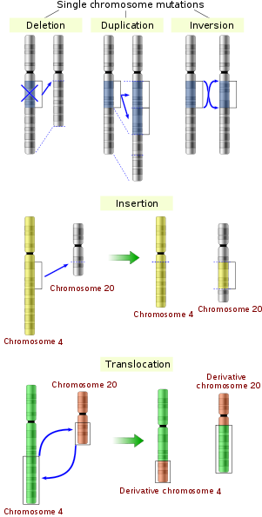

* 1. One of the mutations shown above occurred in a pancreatic cell of an adult, causing a tumour to grow.
     1. Name the type of mutations that occur in body cells. (1 mark)
     2. Could this mutation be passed onto the children of the adult?(1 mark)
     3. Explain your answer. (2 marks)

**Extended Response: 15 Marks**

*Answer ALL QUESTIONS on the lined paper provided. DO NOT WRITE IN PENCIL.*

*Your answer may take the form of:*

* *Appropriate graphic organisers e.g. a table*
* *Clearly labelled and annotated diagrams*
* *A list of points, with sentences which link them*

1. The Greek government is looking to reduce spending in their annual health budget. The current health minister is an elderly gentleman who has not kept himself informed of recent medical advancements. He is astonished to learn that every child born in Greece receives a free genetic screening for a mutation. In a fit of pique, he summarily canceled the testing program. National outrage ensues.
2. Name the genetic disease the screening program aimed to detect, and describe the main signs and symptoms of the disease. 3 marks
3. Name the mechanism of inheritance of the disease. 1 mark
4. The cost of the genetic screening test was mainly due to the amplification of the DNA collected from each person. Cast yourself into the role of the advisor to the minister, and name and describe the process whereby DNA is amplified in a way that he will understand. 8 marks
5. Why does this allele persist in the gene pool of the population? 3 Marks